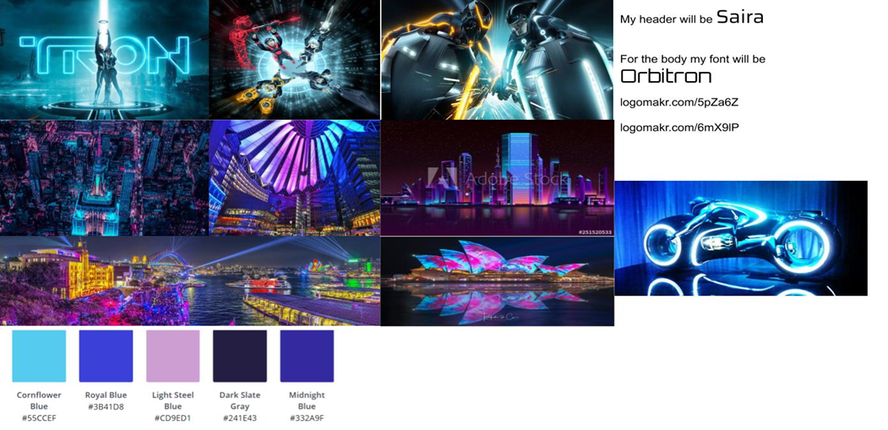

Flynn’s Website

POrtfolio

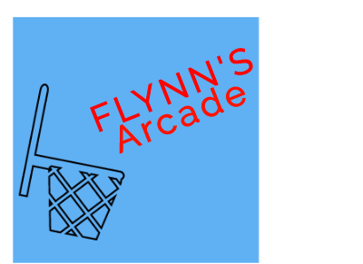Brock Millar| 13/9/2019

Contents

Design Brief 2

Areas of investigation/Research 2-6

Design Sketches 6

Final concept/Design 7

Design changes 8

Evaluation 9

Bibliography 10

### 

## Design Brief

Flynn’s Arcade has been slowly losing money as the trend for accessing video games has moved away from social ‘video game arcades’ to at home ‘video game consoles’ such as the Atari and Commadore 64. Flynn wants to reposition his business as a venue for selling and trading used games. Flynn wants you to design and create ‘alpha phase’ website that communicates his new business. Flynn wanted us to create a website based around Tron and a futuristic setting.

6 criteria

|  |
| --- |
| Use Headlines (wisely) |
| Use images (wisely) |
| Make sure the website is what Flynn wants |
| Number of pages has to be consistent |
| Use key information by using bullet points |
| Provide information like where it is, and email and phone number (contact page) |

## Areas of investigation/Research

We have researched on how to make a websites and, how to code the website using notepad++. During this time we also had to research how to make our own Repositories on GitHub, we also learnt how to use Logomakr to create our websites logos and price tags. We used websites like JB-HI-FI and EB games to look at the designs to help us create our own design.



Bootstrap

In the time that we were creating and designing the website we used a website called bootstrap. We used this website to help us with the code and installation of sliders, css, js and many more. All we needed to do is copy and paste the code into the section were it needed to go.



JB HI FI

This website helped us look at how to design our layout for the website that we’ve been designing. JB HI FI also helped us out with what a websites Contact us now page should look like.



MHS-DEVS-TOOLKIT

This toolkit was designed to help us with the making of our website. The things that the toolkit help me with was getting a color pallet and more.



EB Games

Even though this website didn’t work for us we still were able to see what type of design that we could make through Mr. Jones’s computer and smart board.

GitHub

GitHub is where we commit our work to the website so if the computer crashes we have it all saved onto something other than a school computer. We also use GitHub to look at our work at home, when we saved our work and pushed it we could access it from a different device at home and work on it there.

 LogoMakr

LogoMakr has helped with the creating and designing of what our website logo. When designing the logo you can use all the features like searching for things like a basketball and many more, change the color, write in text and more.

Google Fonts

Google fonts has helped us while we were choosing the fonts that we would like to be for our websites header and body. It was a hard choice because there are 952 fonts to choose from.

 Photoshop

Photoshop is an easy way for you to edit photos on a computer or laptop. It was created in 1988 by two brothers’ john and Thomas knoll. We used Photoshop to help make the slider images, we also used it to help make the ‘PBox’ images.

 WIX

This is an example of another web designer that we could have used. This web development allows people to use HTML5 and they can also use online drag and drop tools.



Visual Studios

Visual studios is a development environment that coders may use. This program may be used to help design web apps, computer programs, websites and many more.

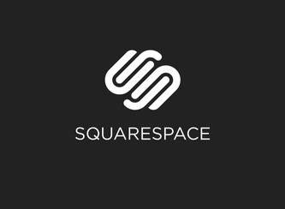Squarespace

Squarespace is a company that’s based out of New York City. It provides software as a service to programmers for website designing (building). The people that use this website use pre-built website templates so they can create their own website.

 Drupal

Drupal is a free and open source website that helps with web design framework. It holds a 2.3% back end of framework for websites worldwide. This helps with people for personal reasons, political reasons and more.

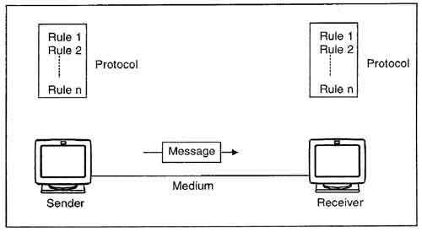

Data Communications

Data communication is the shifting of a communication system from analog to digital. The core of data communication is communication software. Data communication also refers to the exchange of data between a source and a receiver via form of transmission media like a wire cable.

## 

## 

## Design Sketches

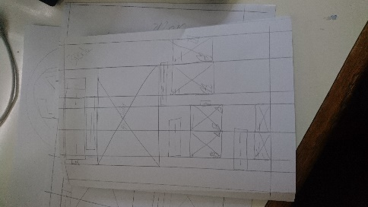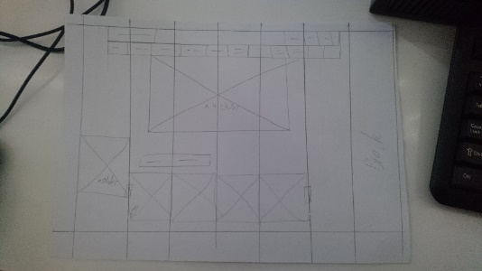These designs are something what my logo was going to look like. Even though I didn’t use any of them they still inspired me to come up with the new logo with a basketball hop and the words ‘Flynn’s Arcade’ pointing down on an angle at the like some had taken a 3pt. This is a picture a wireframe which is a schematic. That means that it’s a diagram of what my website would look like when you’re on your mobile phones. This image here shows us what the layout or design will be for the website. Just like the image before it is also a wireframe, we made these so we could see what the website would look like on a computer or laptop.

## Final concept/Design



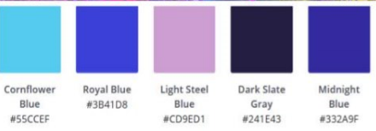

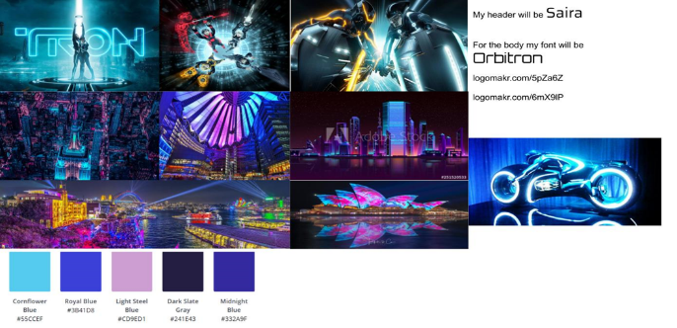While I was creating my sketches for the logo I wasn’t here to have a final design and concept so I asked sir what website everyone was using he said they are using LogoMakr. When I got onto the website I was told to play around and get used to it, after about ten minutes Mr. Jones told me to start on my design for the logo and after about 6 attempts at trying to get the right type of logo I came up with this.

## 

## Design changes

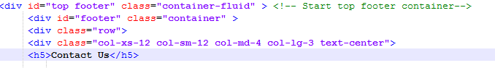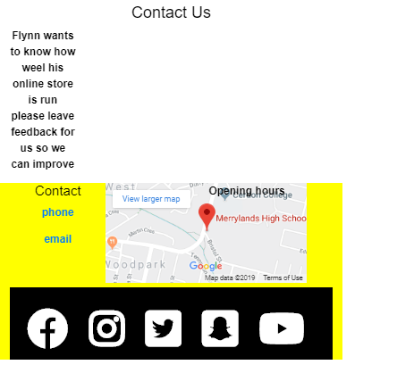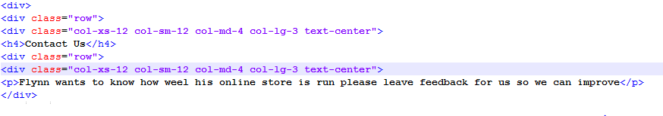The changes that I made to my website were to help improve on what was good to make it something that is great. Somethings were just simple editing with photo shop but others like my contact page, was an internal and coding. This is a problem that I had come across while I was writing information on my contact page. The coding that I had wasn’t right for the small sentence that I wanted the consumers to see so that they could write an email or call, to give us feedback. I kept going back and forth between the codes.

Making mistakes like creating icons for ways to contact us such as Facebook and Instagram, I would place a hyperlink their and it would turn from white to blue and the sizing would change as well. 

These changes had a good impact after I fixed them because the website would go back to normal and also because my website would look like a simple website designed by a beginner.

## Evaluation

## When the Mr. Jones told us that we had to stop working on the website code and start on our portfolio’s everyone was so regretful because they didn’t finish their sliders or their Pboxes. I was happy because my website was quite good and what I thought of it was I had done a great job for my first time at designing and coding a website using industry level code editor.

## 

## Some bad features after finishing my website was that the contact page was still not quite what it’s meant to be. Even though all the measurements for the invisible box that it would go into.

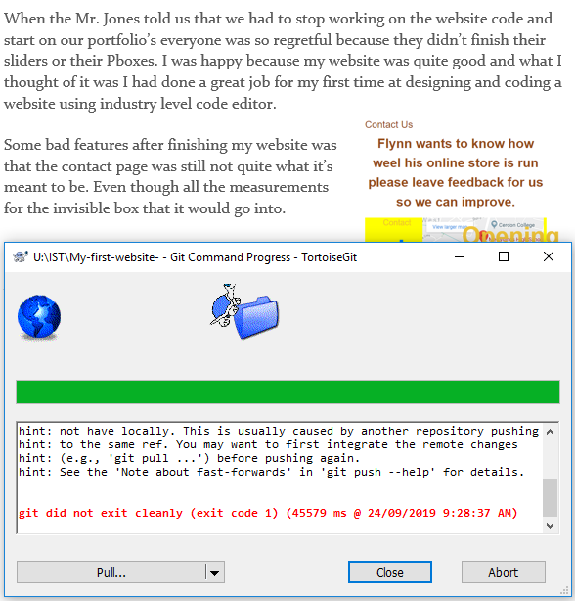During our process of the website building when we were finishing we used GitHub to commit our so it wouldn’t get lost if the computer or laptop had stopped working. But sometimes it wouldn’t let me commit using the master-Git.

After 7 weeks of designing and learning how to create a website we then started on this portfolio which sir said was due on the 24/09/19, so we could start our wonderful new topic early for next term which is VR.

## Bibliography:

<https://tron.fandom.com/wiki/Flynn's_Arcade>

<https://logomakr.com/>

<https://www.jbhifi.com.au/>

<https://ebgames.com.au/>

<https://getbootstrap.com/>

<https://www.google.com.au/maps/@-33.8482439,150.9319747,10z?hl=en>

<https://www.google.com.au/imghp?hl=en&tab=ri&ogbl>

<http://www.mhs-devs.com.au/designToolKit/>

<https://fonts.google.com/>

<https://www.researchgate.net/publication/275276848_Data_Communication_Software-_Role_and_functions>